7 a side Boston Schools Sports Partnership Tournament
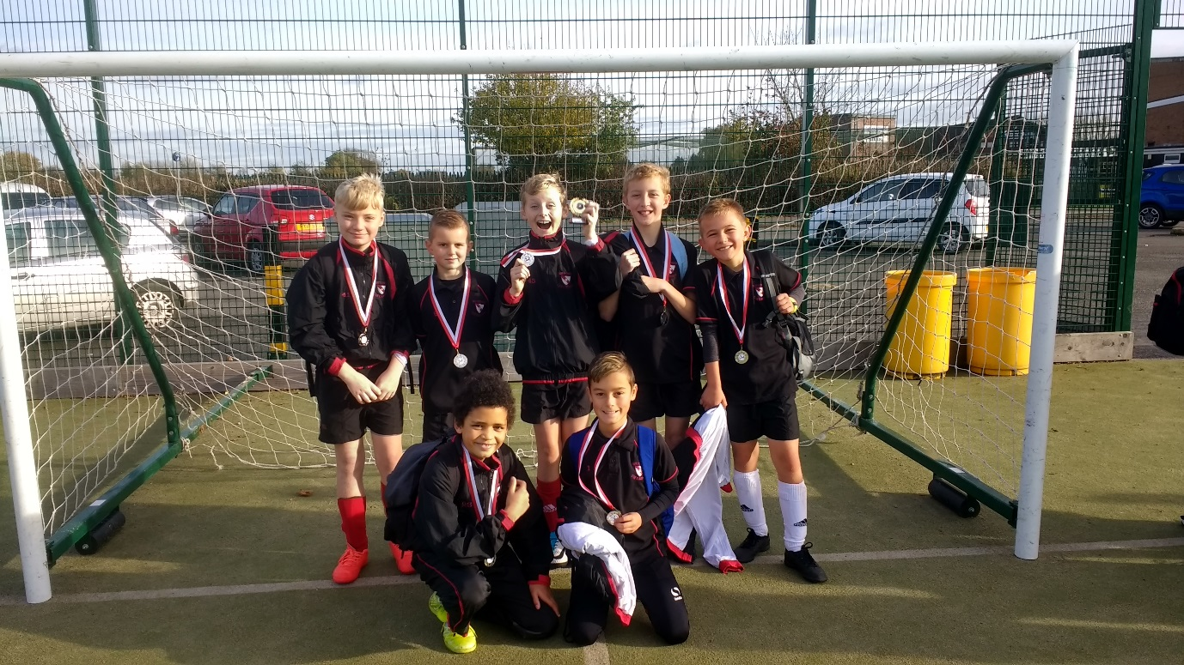

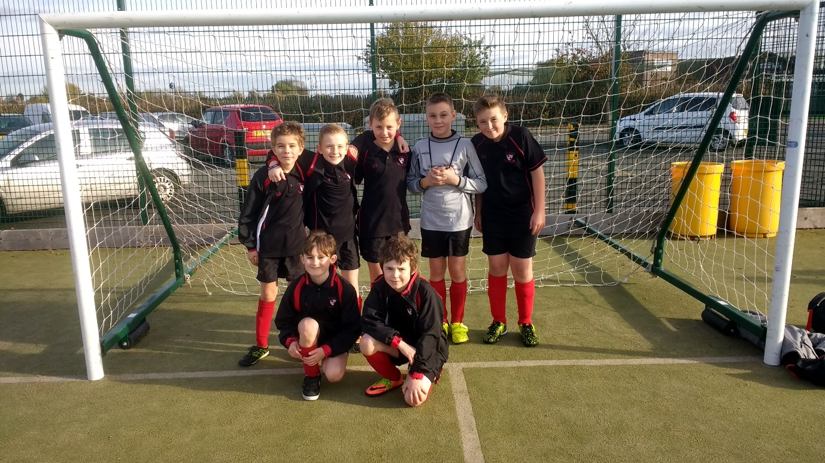
Both teams performed really well and were a credit to our school. The ‘A’ team won through to the final, which they eventually lost 1 -0 in a very close game that was decided on a ‘golden goal’ after the game had finished 0-0 at full time.
Well done to both teams.

