
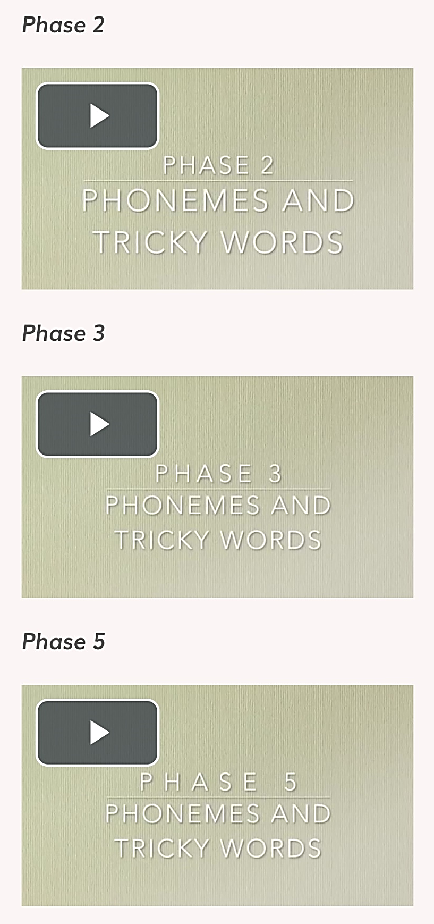
Children in Reception and Key Stage 1 have shared with you the pronunciations of the phonemes they learn in school.
We have shared these on our school website to support parents and carers when practising these phonemes at home.
Why not head over to our website to see what the children have been getting up to…
On the school website page (www.butterwick.lincs.sch.uk), under the ‘Parents/Carers’ tab, click ‘Curriculum’, then ‘English’ and you will see a ‘Phonics’ tab with lots of information about how we teach phonics at Butterwick and also the videos of the children pronouncing these phonemes.
https://www.butterwick.lincs.sch.uk/page/?title=Phonics&pid=176
Phoneme Pronunciation

